MAX_POSITIONS = 20 # simultaneous positions

DELAY = 3 # delay before the search of highest close

MAX_DELAY = 10 # upper limit for the search of highest close

MAX_DIT = 21 # max trading days in trade

STOP_LOSS = -0.50

PROFIT_TARGET = 0.50

MIN_ENTRY_PRICE = 0 # min. price on entry

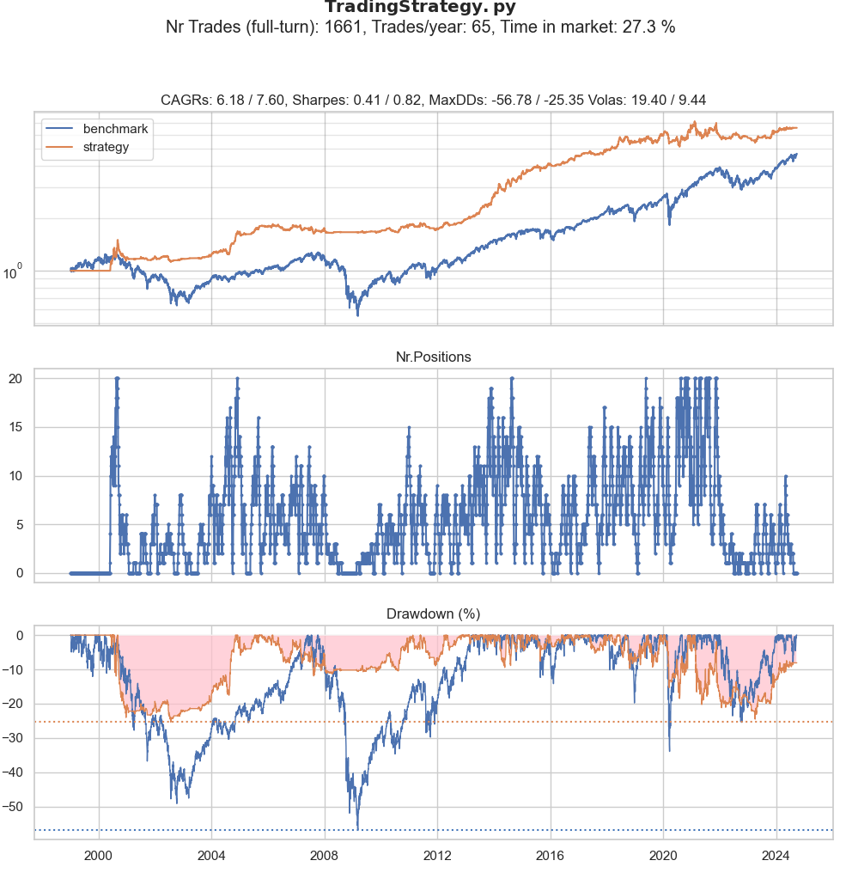

Days in market: 5387 Total days: 6473

Average per day: 0.0

Number of symbols: 3354

Total return: 1.9959890431341591

Nr.trades: 1661

daily return: 0.0012016791349392891

Average trade: 0.03497112

Average per year: 0.07770573750499121

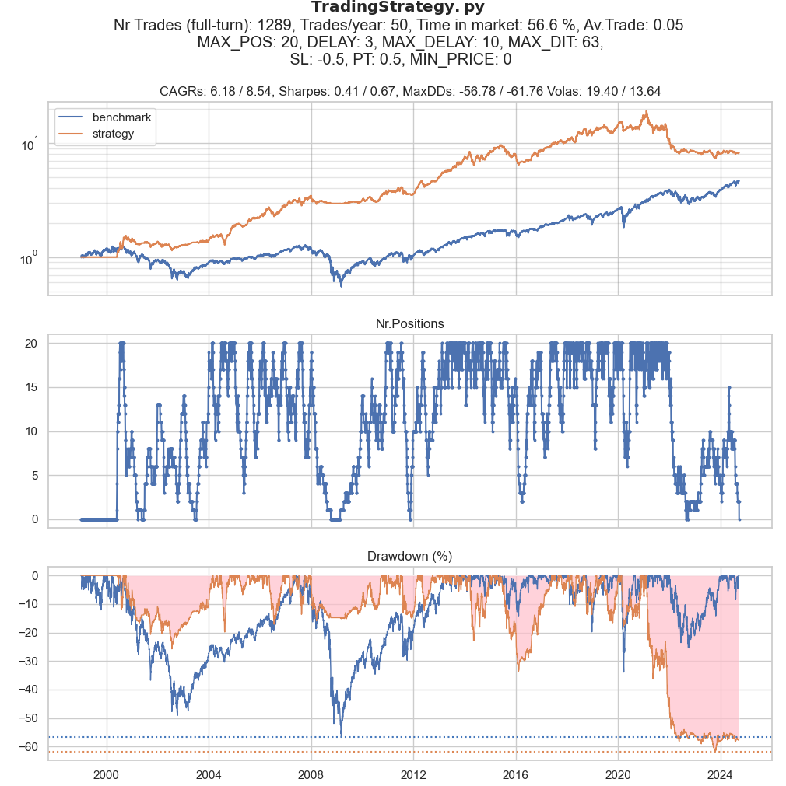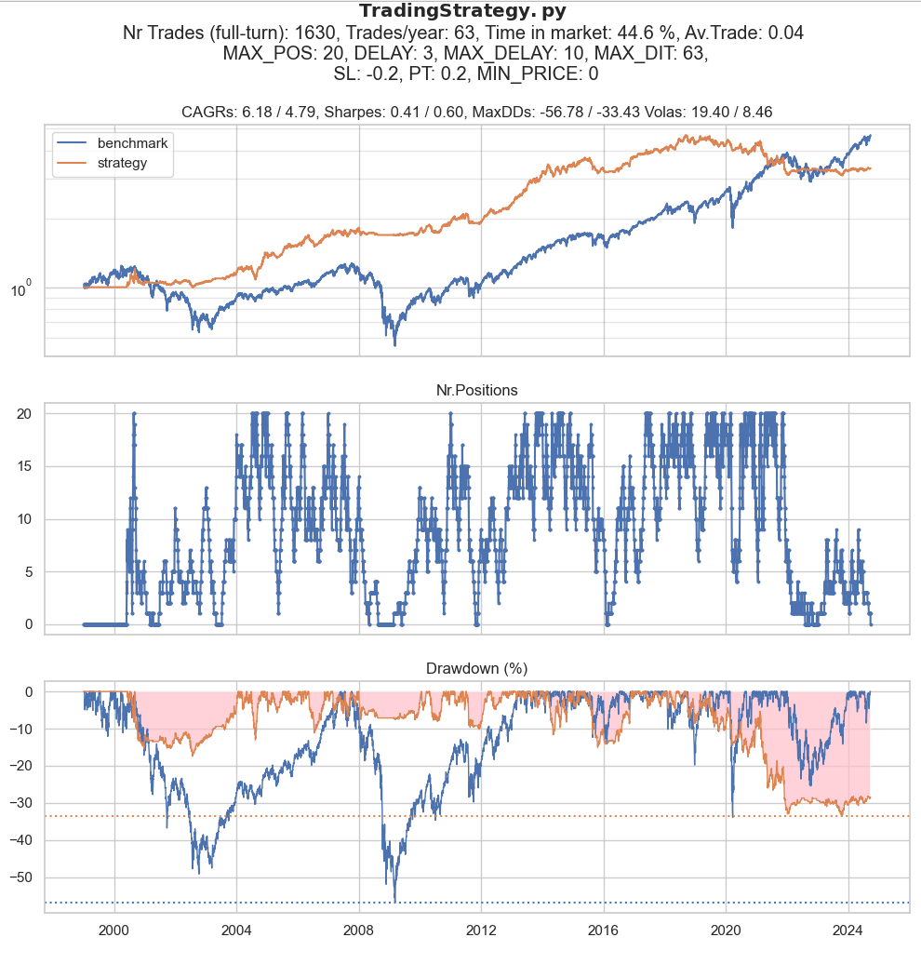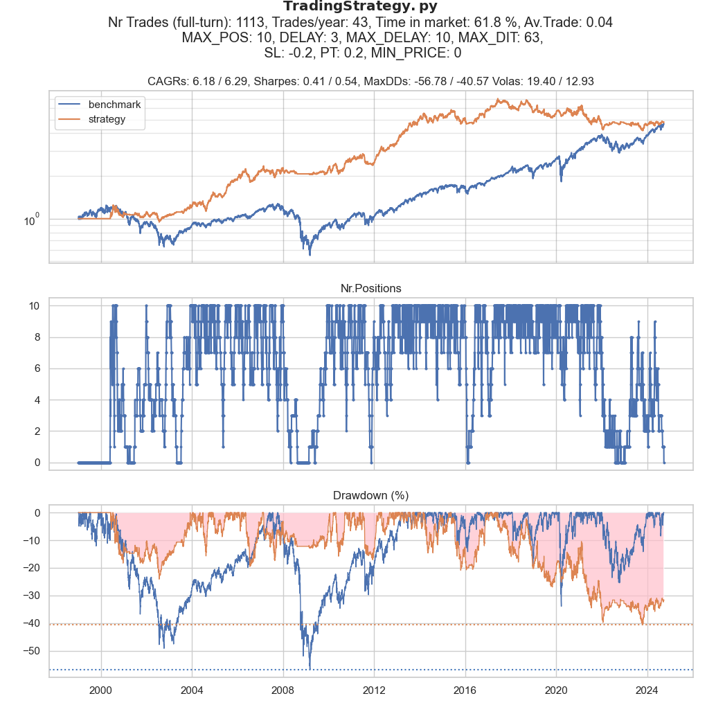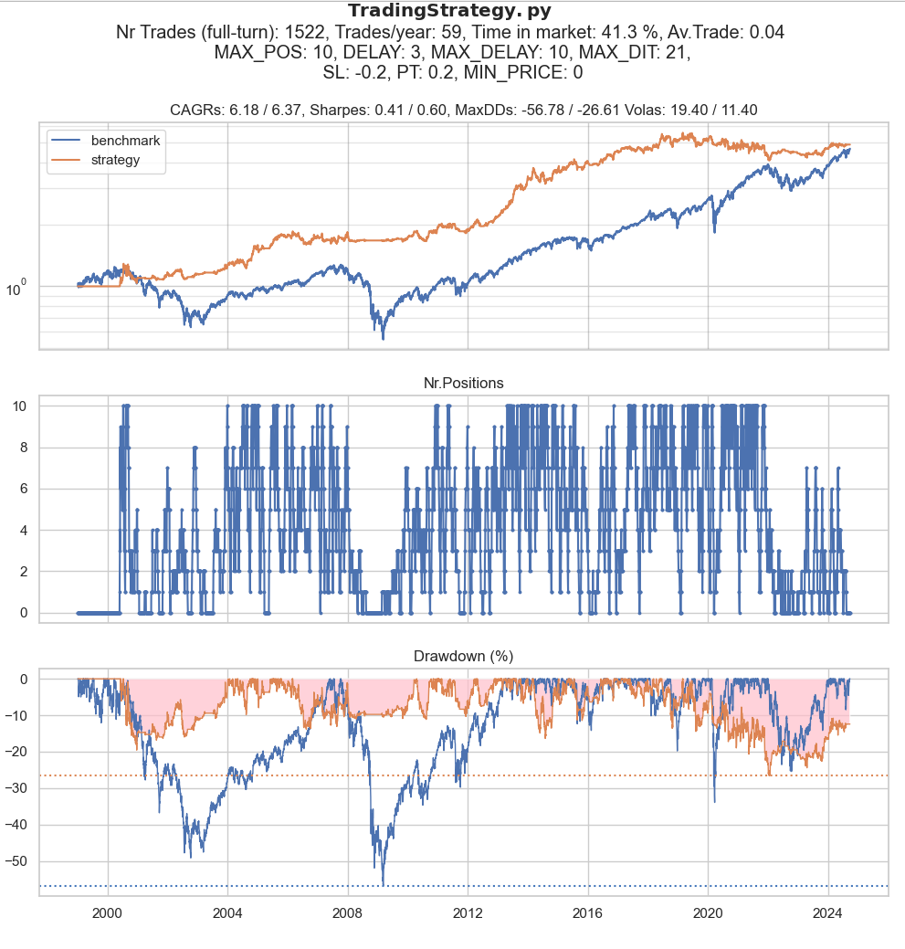

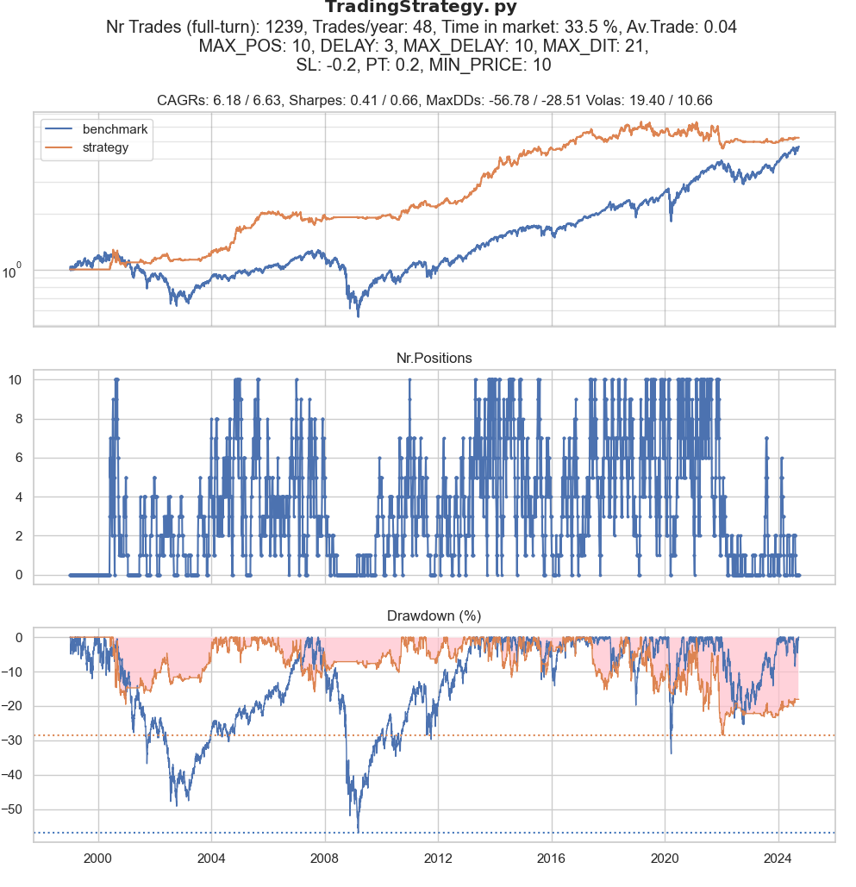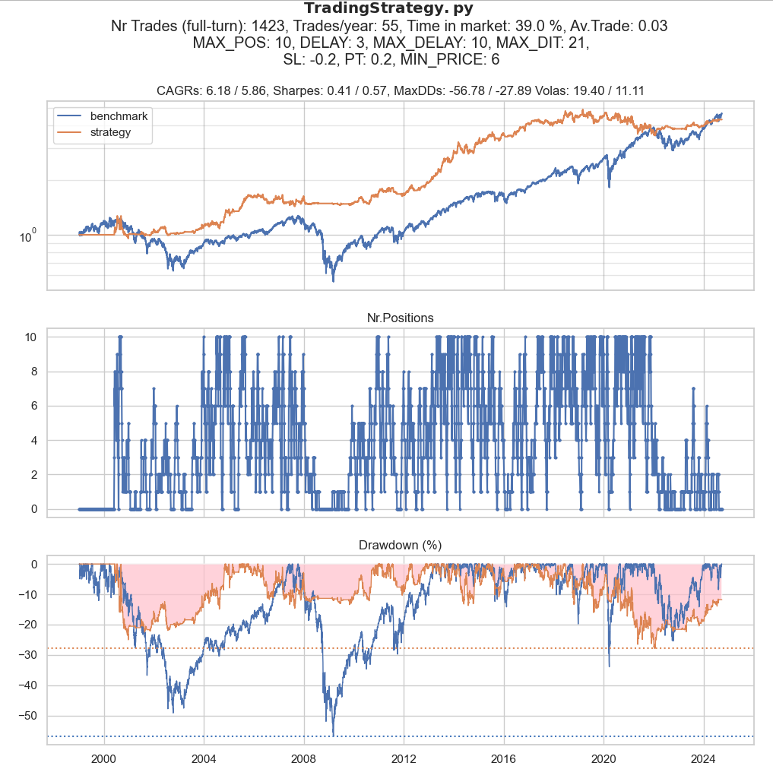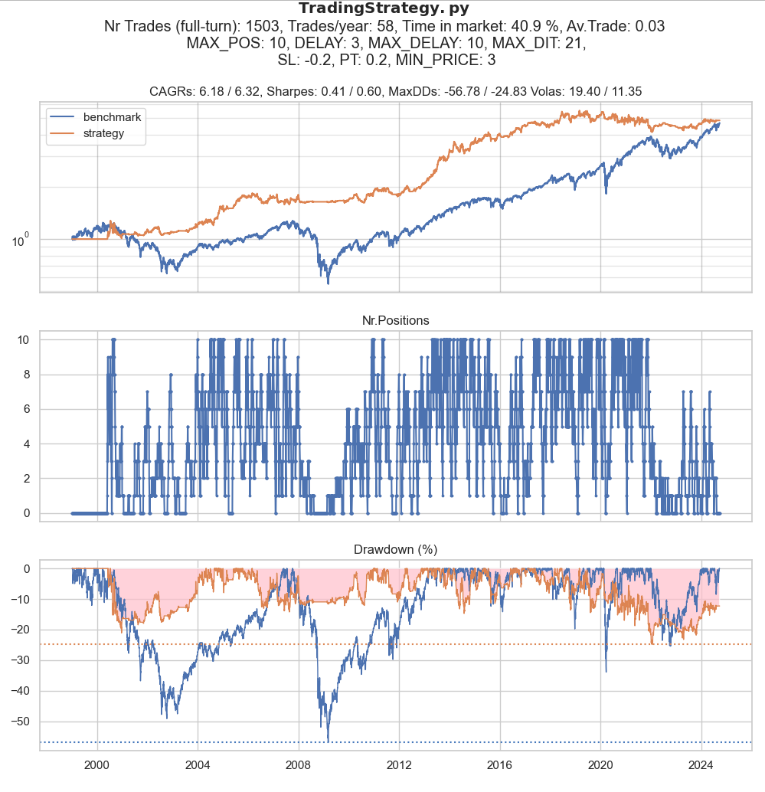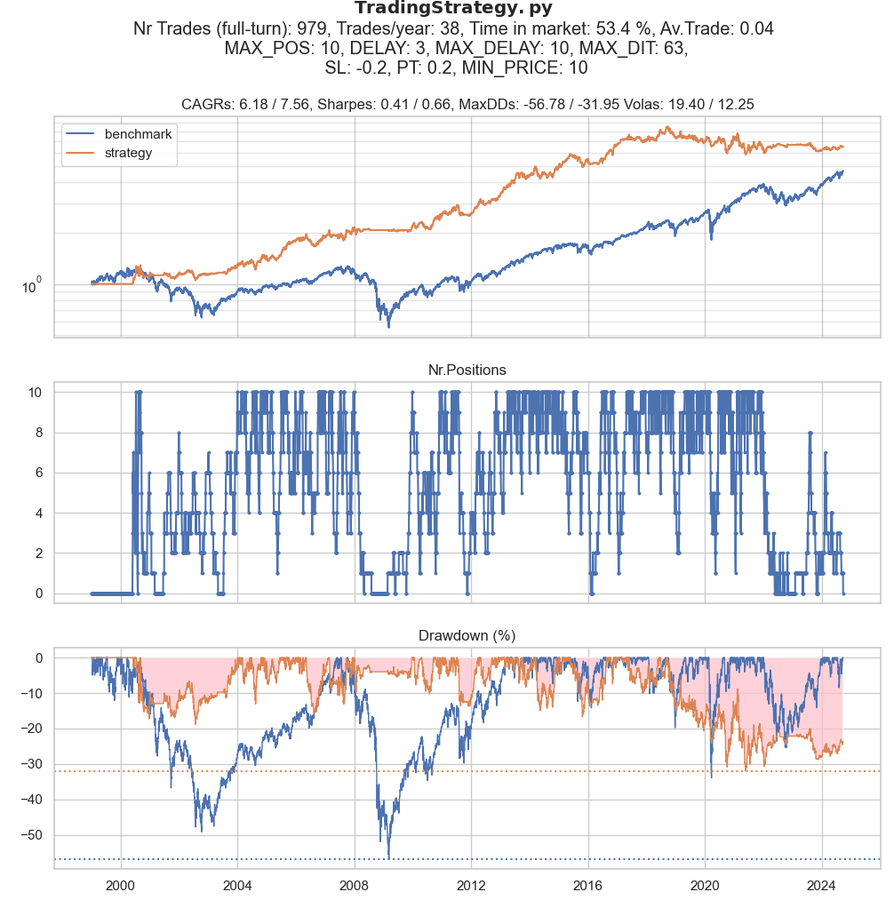

The same parameters, but stocks with history shorter than 100 days are ignored.

Does this lead to look ahead bias? Probably, yes, but results are similar:

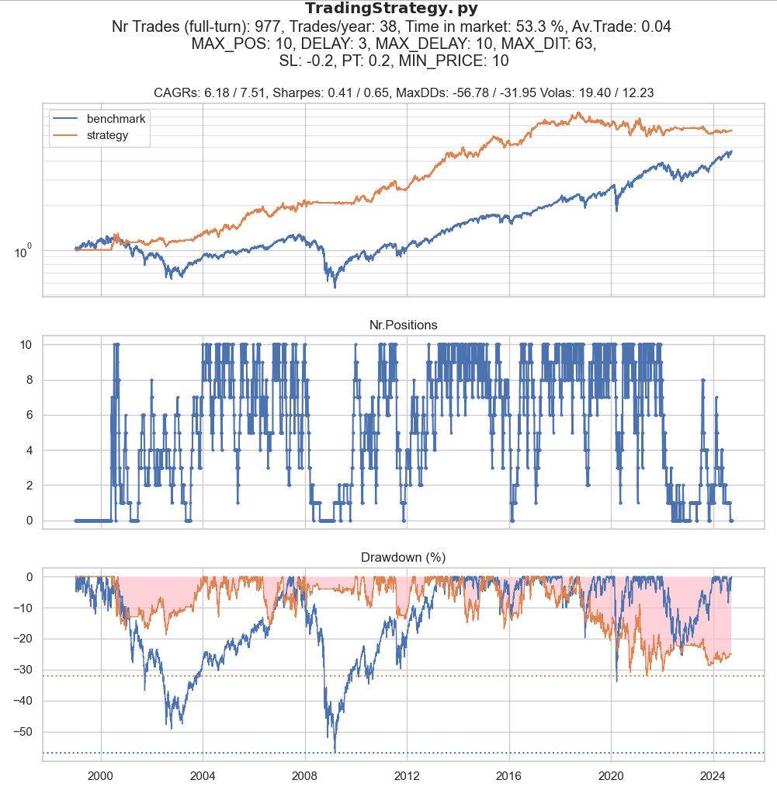

Trade all symbols from Norgate, not filtering out the ones that are not in IPO.

This seems to me wrong, as we don’t know how exactly a symbol appears in Norgate: is it IPO or may be company split or something else?

Anyway, let’s see how it looks like. The article <https://www.quantitativo.com/p/the-edge-in-trading-ipos-18-annual> also takes all Norgate symbols, so we want to compare the results.

**The average daily turnover of the first 10 days is > 1 Mio.:**

**Again, The average daily turnover of the first 10 days is > 1 Mio., but wider SL and PT:**

Number of symbols to trade: 3202

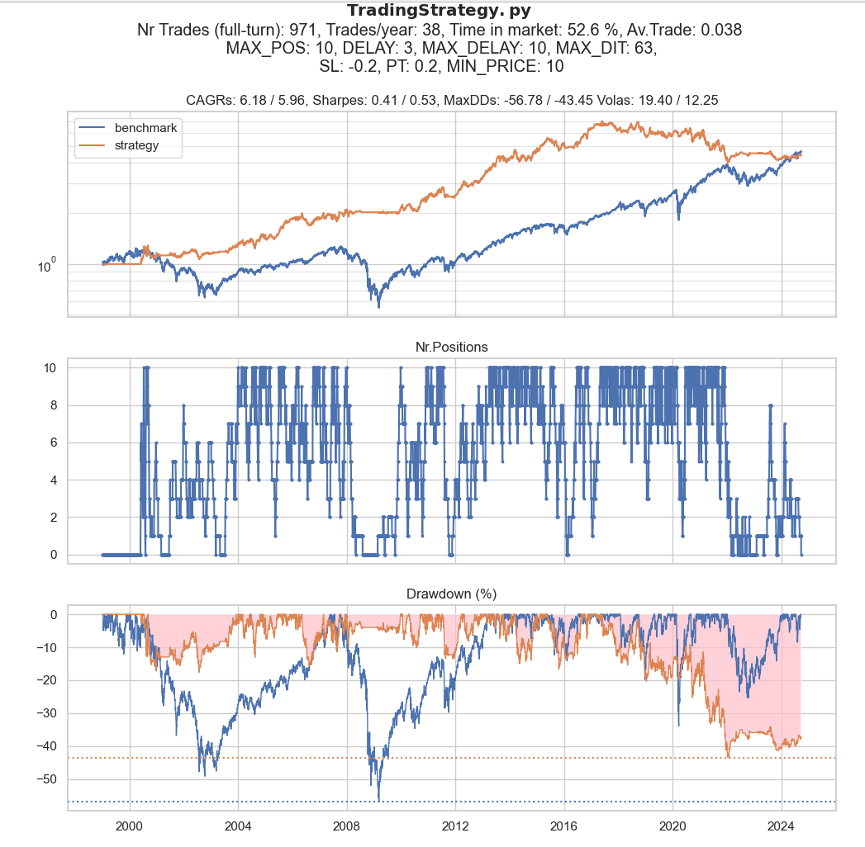

**The same, but for all Norgate symbols:**

**Number of symbols to trade: 8799**

